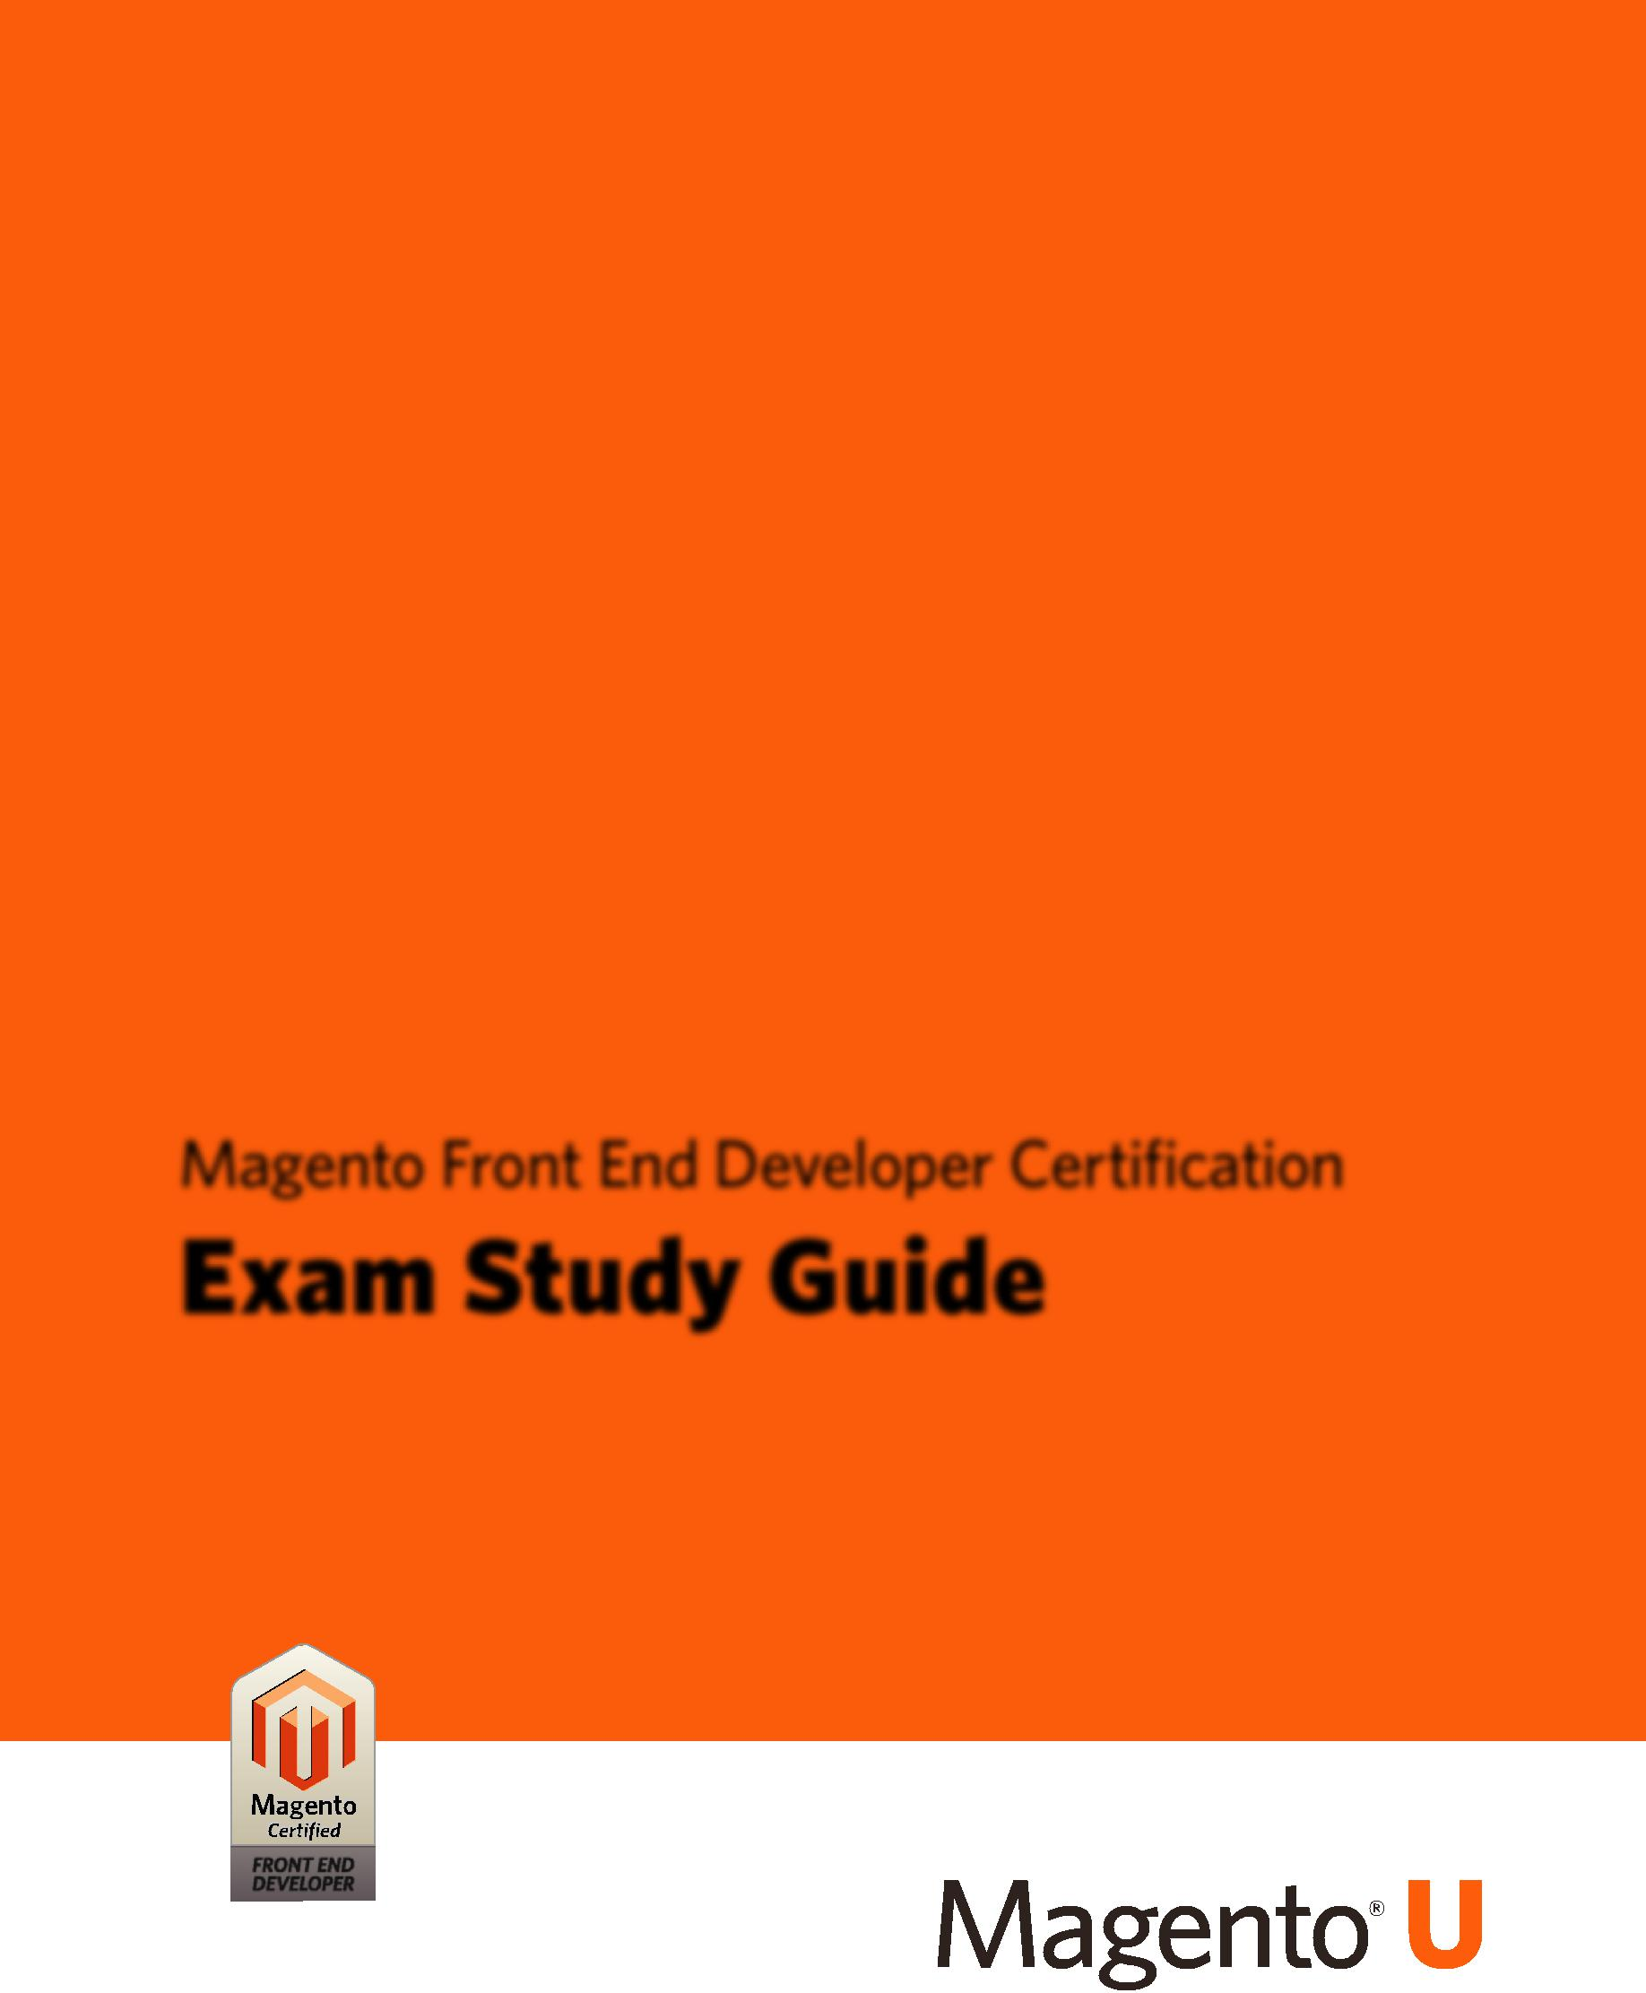

Magento Front End Developer Certification

**Exam Study Guide**

© Copyright 2013 X.commerce, Inc. All rights reserved. 04-01-13

*Table of Contents*



**Table of Contents**



Magento Frontend Developer Certification *Study Guide, v. 1.0* *© 2013 X.commerce, Inc.* *iii*

*Table of Contents*



*iv* *Magento* Frontend Developer Certification *Study Guide*, v. 1.0 *© 2013 X.commerce, Inc.*

*Introduction*



**Introduction**

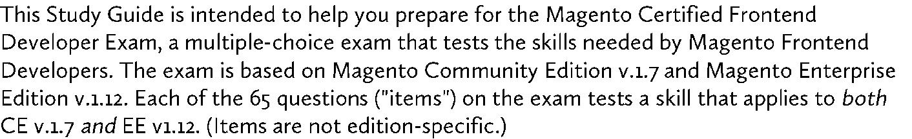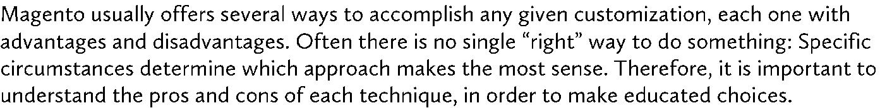

-



-



-



|  |  |
| --- | --- |
| Magento Frontend Developer Certification *Study Guide, v. 1.0* *© 2013 X.commerce, Inc.* | 1 |

*Prerequisites*



**Prerequisites**



-



-



-



-



-



-



-



-



-



2 Magento Frontend Developer Certification *Study Guide*, v. 1.0 *© 2013 X.commerce, Inc.*

*Objectives (Skills)*



**Objectives (Skills)**



**1. Use the Magento Design Fallback System**

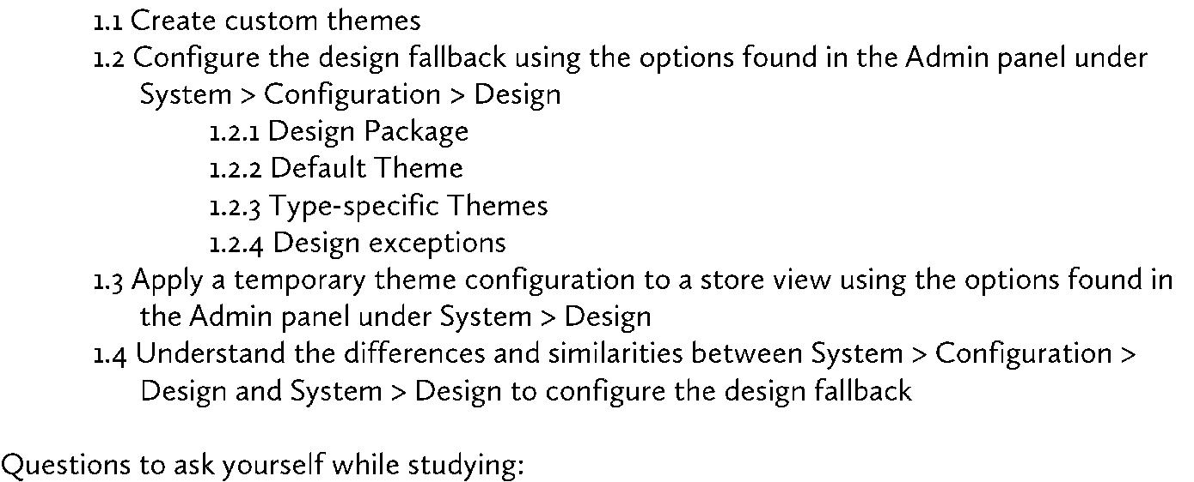

-



-



-



-



-

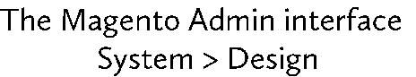

o



o



o



o



o

-

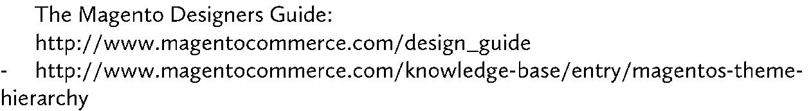

|  |  |
| --- | --- |
| Magento Frontend Developer Certification *Study Guide, v. 1.0* *© 2013 X.commerce, Inc.* | 3 |

*Objectives (Skills)*



**2. Use Layout XML to Customize a Theme**

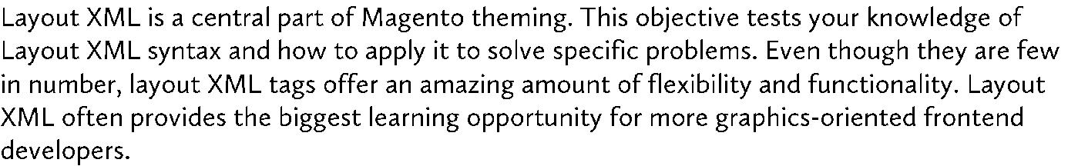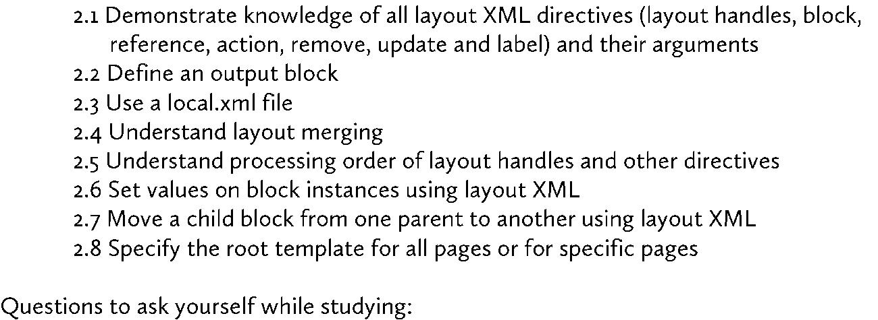

-

name



as



-



-



-



-



-



-

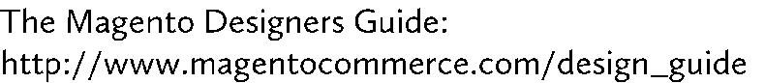

-



-



-



-



o



o



4 Magento Frontend Developer Certification *Study Guide*, v. 1.0 *© 2013 X.commerce, Inc.*

*Objectives (Skills)*



**3. Create and Customize Template Files**

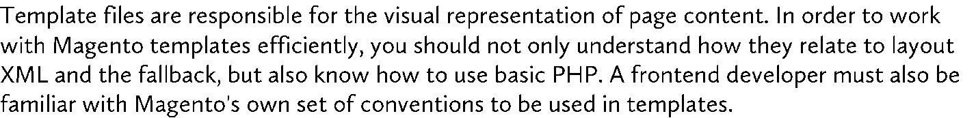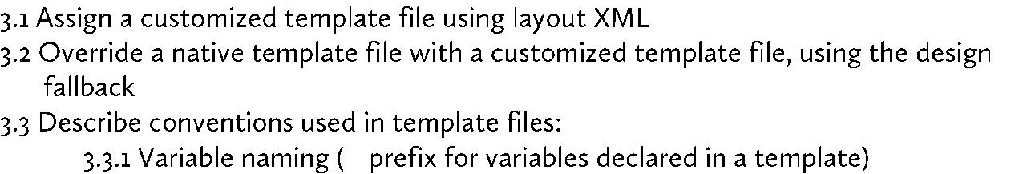

_



if (…): endif;



<?php <? <% 



-



* $this



-



**4. Effectively Use the Magento Block-Template Design System**

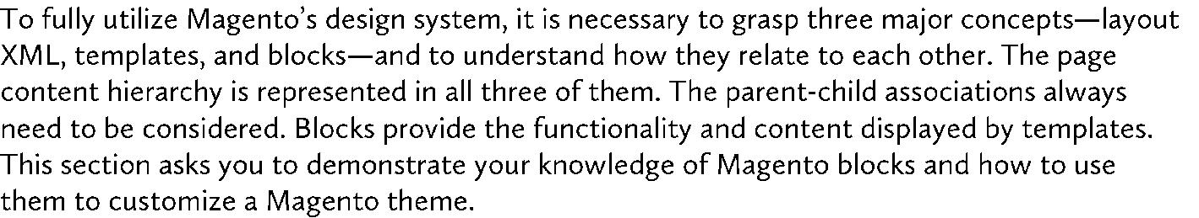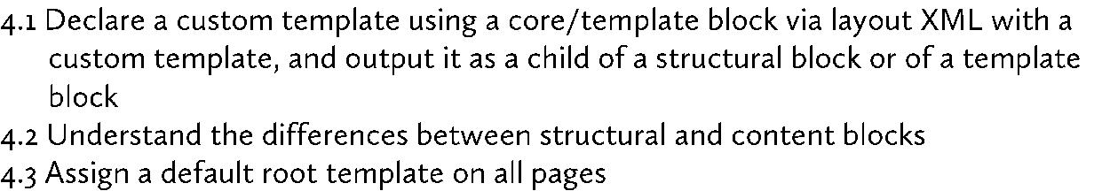

|  |  |
| --- | --- |
| Magento Frontend Developer Certification *Study Guide, v. 1.0* *© 2013 X.commerce, Inc.* | 5 |

*Objectives (Skills)*

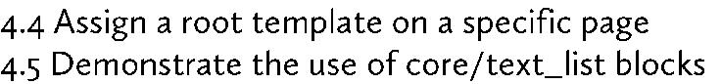

-



-



-



-



-



-



-



-



1. **Identify Where to Locate Files and Create New Files in the Theming-related Directory Structure**

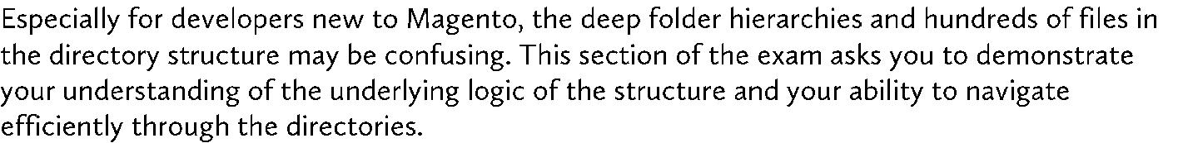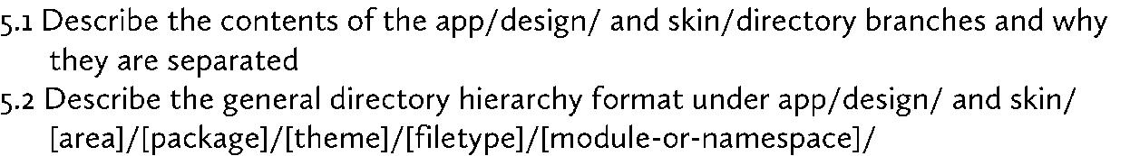

-



-



-



-

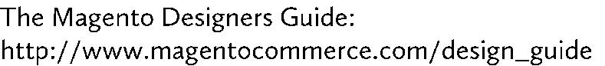

6 Magento Frontend Developer Certification *Study Guide*, v. 1.0 *© 2013 X.commerce, Inc.*

*Objectives (Skills)*



1. **Customize and Create JavaScript Within the Magento Framework**

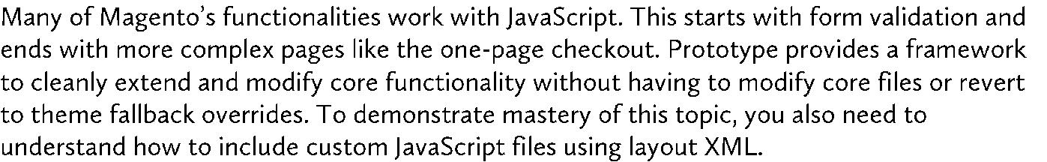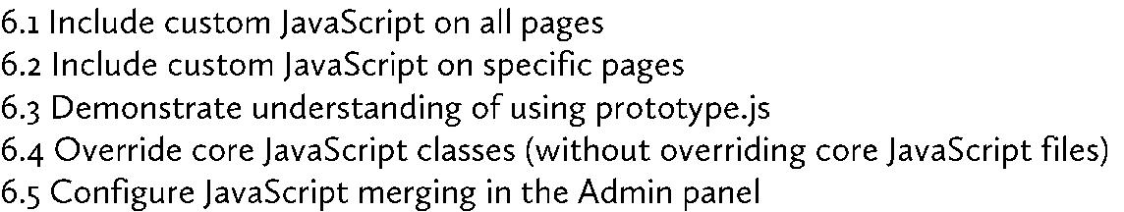

-



-



-



-



-



-

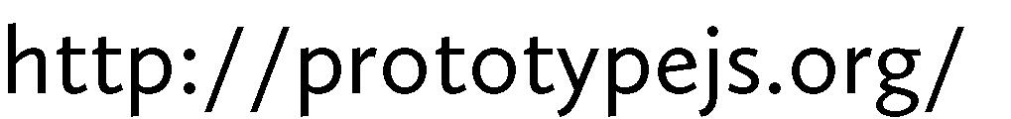

-

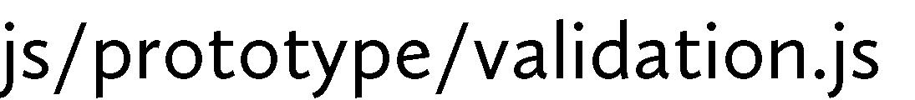

-

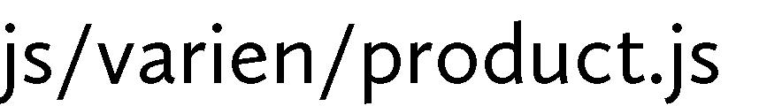

-



-



**7. Use CSS Effectively to Customize Magento Look and Feel**



|  |  |
| --- | --- |
| Magento Frontend Developer Certification *Study Guide, v. 1.0* *© 2013 X.commerce, Inc.* | 7 |

*Objectives (Skills)*

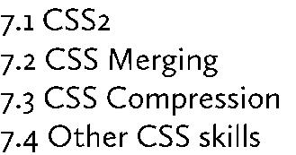

-



-



-



-



**8. Customize the Look and Feel of Specific Magento Pages**

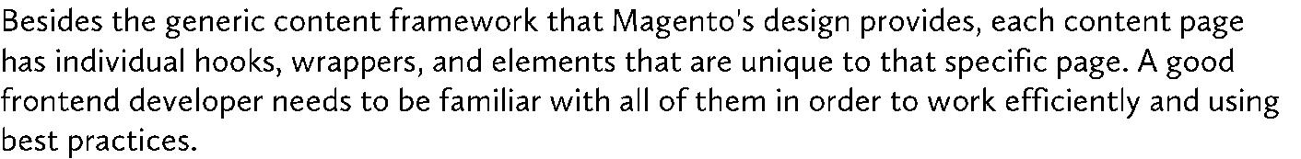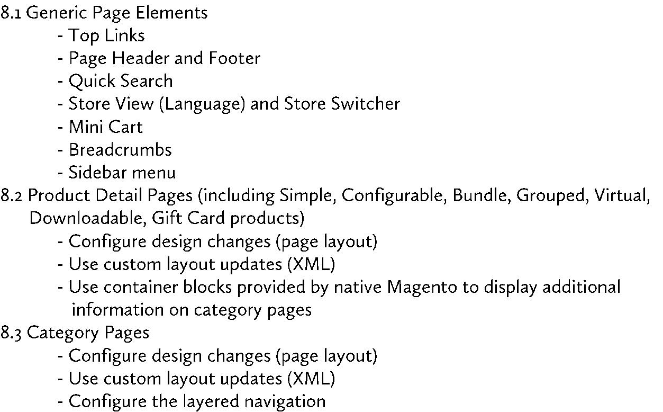

8 Magento Frontend Developer Certification *Study Guide*, v. 1.0 *© 2013 X.commerce, Inc.*

*Objectives (Skills)*

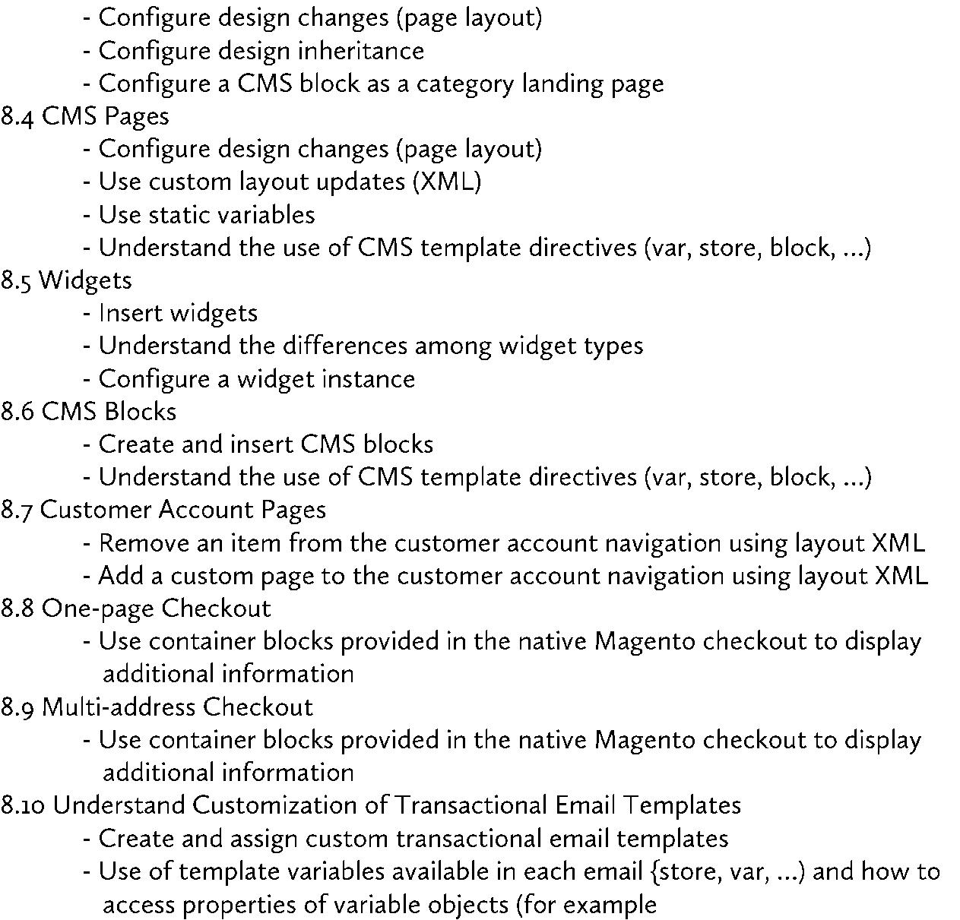

var

order.getCustomer.getName)



-



-



-



-



-



-



|  |  |
| --- | --- |
| Magento Frontend Developer Certification *Study Guide, v. 1.0* *© 2013 X.commerce, Inc.* | 9 |

*Objectives (Skills)*



1. **Correctly Use the Admin Configuration Scopes (Default/Website/Store View Fallback)**



-



-



-



o

**10. Implement Internationalization of Frontend Pages (CE + EE)**

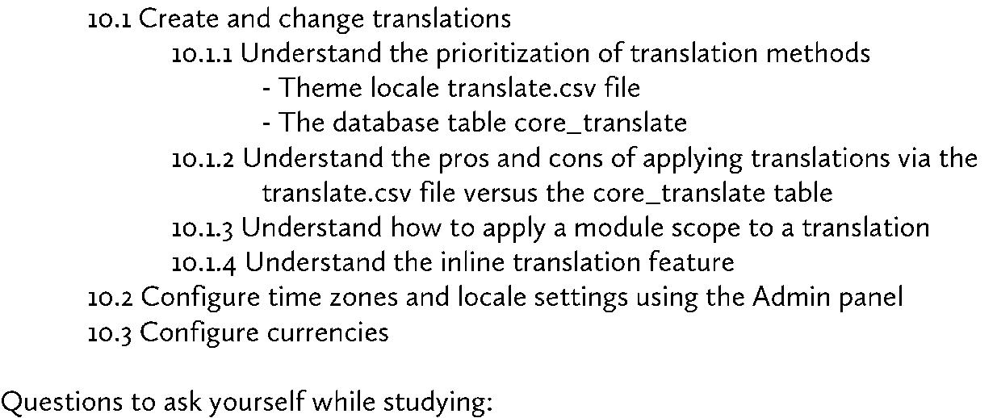

-



-



-



-



-



-



-



10 Magento Frontend Developer Certification *Study Guide*, v. 1.0 *© 2013 X.commerce, Inc.*

*Objectives (Skills)*



-



-



-



o



|  |  |
| --- | --- |
| Magento Frontend Developer Certification *Study Guide, v. 1.0* *© 2013 X.commerce, Inc.* | 11 |

*Objectives (Skills)*



**Sample Questions**

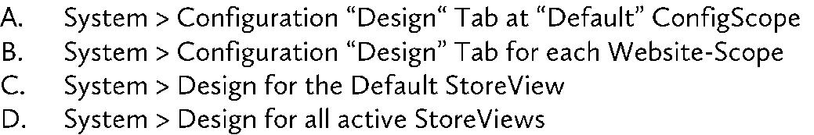

<customer_account translate="label">

<reference name="left">

<block type="customer/account_navigation" name="customer_account_navigation" template="customer/account/navigation.phtml">

<action method="addLink"

module="customer"><name>account</name><path>customer/account/</path><la

bel>Account Dashboard</label></action>

</block>

</reference>

</customer_account>

<customer_account>

<reference name="customer_account_navigation"> <action method="addLink" module="wishlist">

<name>wishlist</name>

<path>wishlist/</path>

<label>My Wishlist</label>

</action>

</reference>

</customer_account>

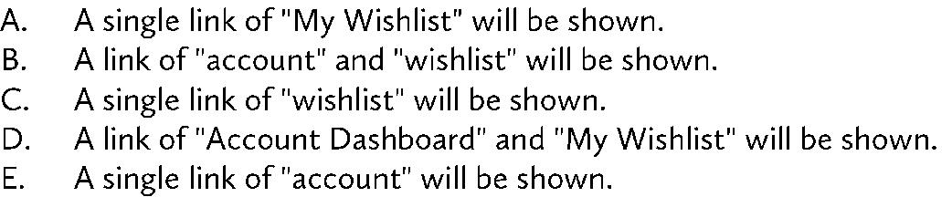

12 Magento Frontend Developer Certification *Study Guide*, v. 1.0 *© 2013 X.commerce, Inc.*

*Objectives (Skills)*

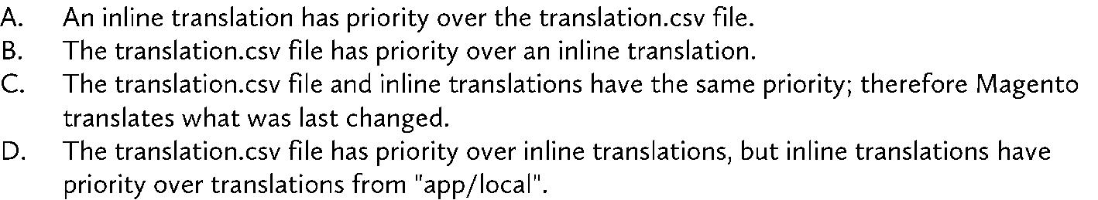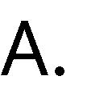

<action method="getTemplate">page/1column.phtml</action>

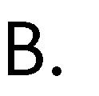

<action

method="getTemplate"><template>page/1column.phtml</template>

</action>

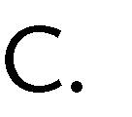

<action

method="setTemplate"><template>page/1column.phtml</template>

</action>



<action method="setTemplate">page/1column.phtml</action>



|  |  |
| --- | --- |
| Magento Frontend Developer Certification *Study Guide, v. 1.0* *© 2013 X.commerce, Inc.* | 13 |

*Objectives (Skills)*



**Answers to Sample Questions**

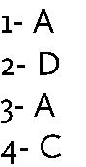

14 Magento Frontend Developer Certification *Study Guide*, v. 1.0 *© 2013 X.commerce, Inc.*